# AZURE MAJOR PROJECT 01

* Create a Resource group by Name (rg01)
* Create two virtual network's using different address space.
* Create two VM's (one Linux and one Windows) in each created Virtual Networks above respectively.
* Create blob storage along with the below file share:-
* Create a File Share (share01) and mount on the window's VM.
* Create a network Security group and attach it to the respective Subnets of (Linux & Windows) VM.
* Configure an inbound security port rule to allow (RDP & SSH).
* Create Peering between the two Virtual Networks.
* Create a Recovery Services vault (Rsv01) in the Resource Group (rg01).
* Define Custom policy for Window VM Backup.
* Setup Backup for the Virtual Machine (Windows) and ensure backup is completed successfully.
* Restore new VM from the backup and delete the older vm.
* Apply a lock on the (rg01) and test if you are allowed to delete any resource.
* Remove the Lock and delete all the resources after completion of your practical.

Output - Create a Word Document and attach all the screenshots of the above activity along with one liner description.

* Resource group:

A Resource group is simply a logical construct that groups multiple resources together so they can be managed as a single entity based on lifecycle and security.

* Resource group rg01 is created.

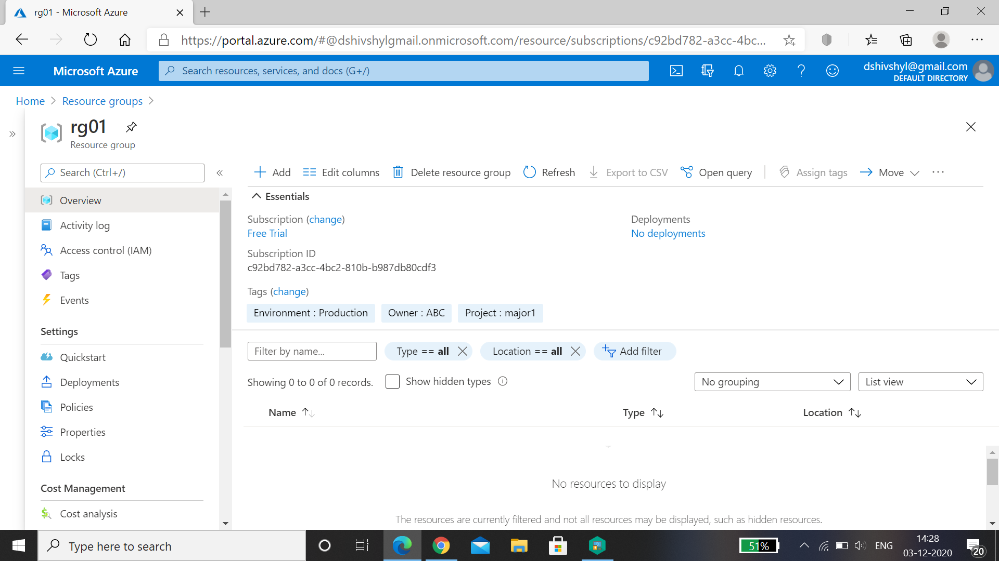

* Virtual Network:

A virtual network is a network where all devices, servers, virtual machines, and data centers that are connected are done so through software and wireless technology.

* virtual network's are created using different address space.

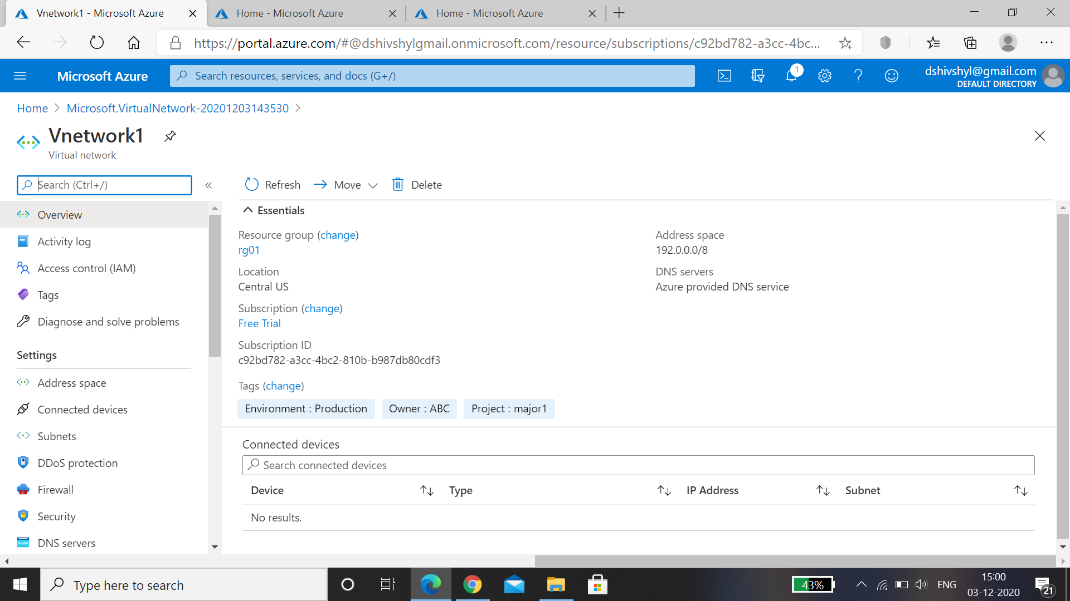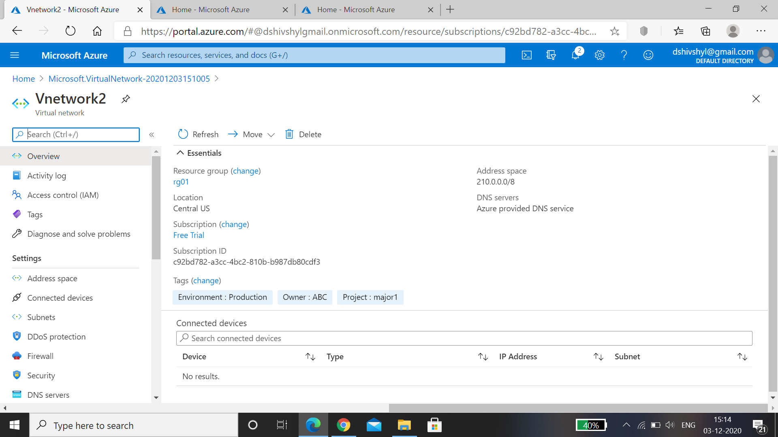

* Virtual Machine:

A virtual machine is an emulated computer system created using software. It uses physical system resources, such as the CPU, RAM, and disk storage, but is isolated from other software on the computer.

* VM01 Windows and VM02 linux Virtual Machine is created.

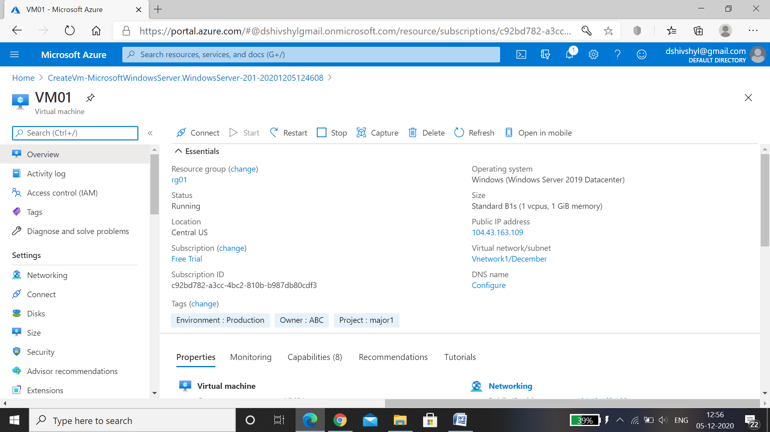

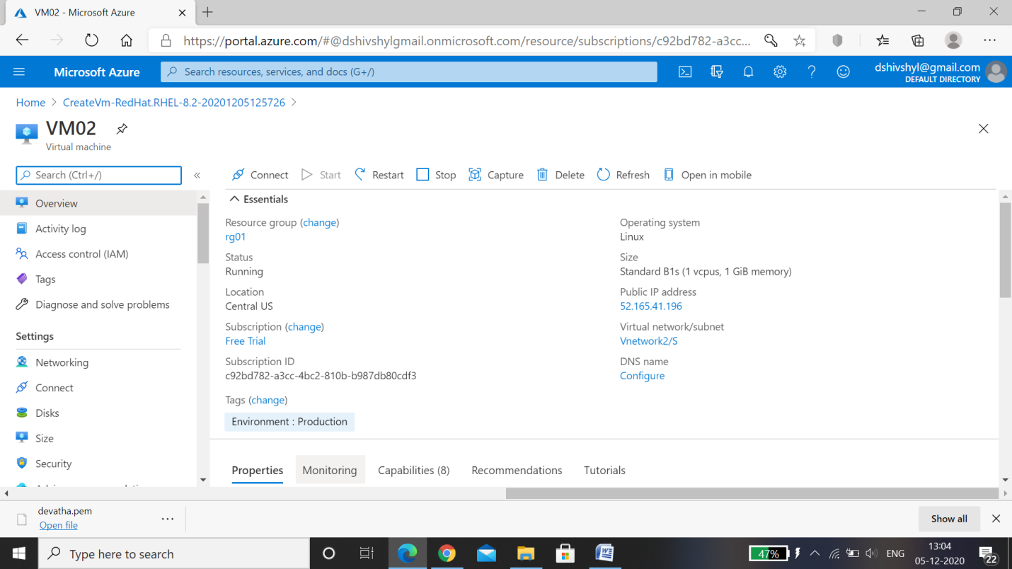

* Blob Storage:

Blob storage is a feature in Microsoft Azure that lets developers store unstructured data in Microsoft's cloud platform. This data can be accessed from anywhere in the world and can include audio, video and text. Blobs are grouped into "containers" that are tied to user accounts.

* Blob storage is created.

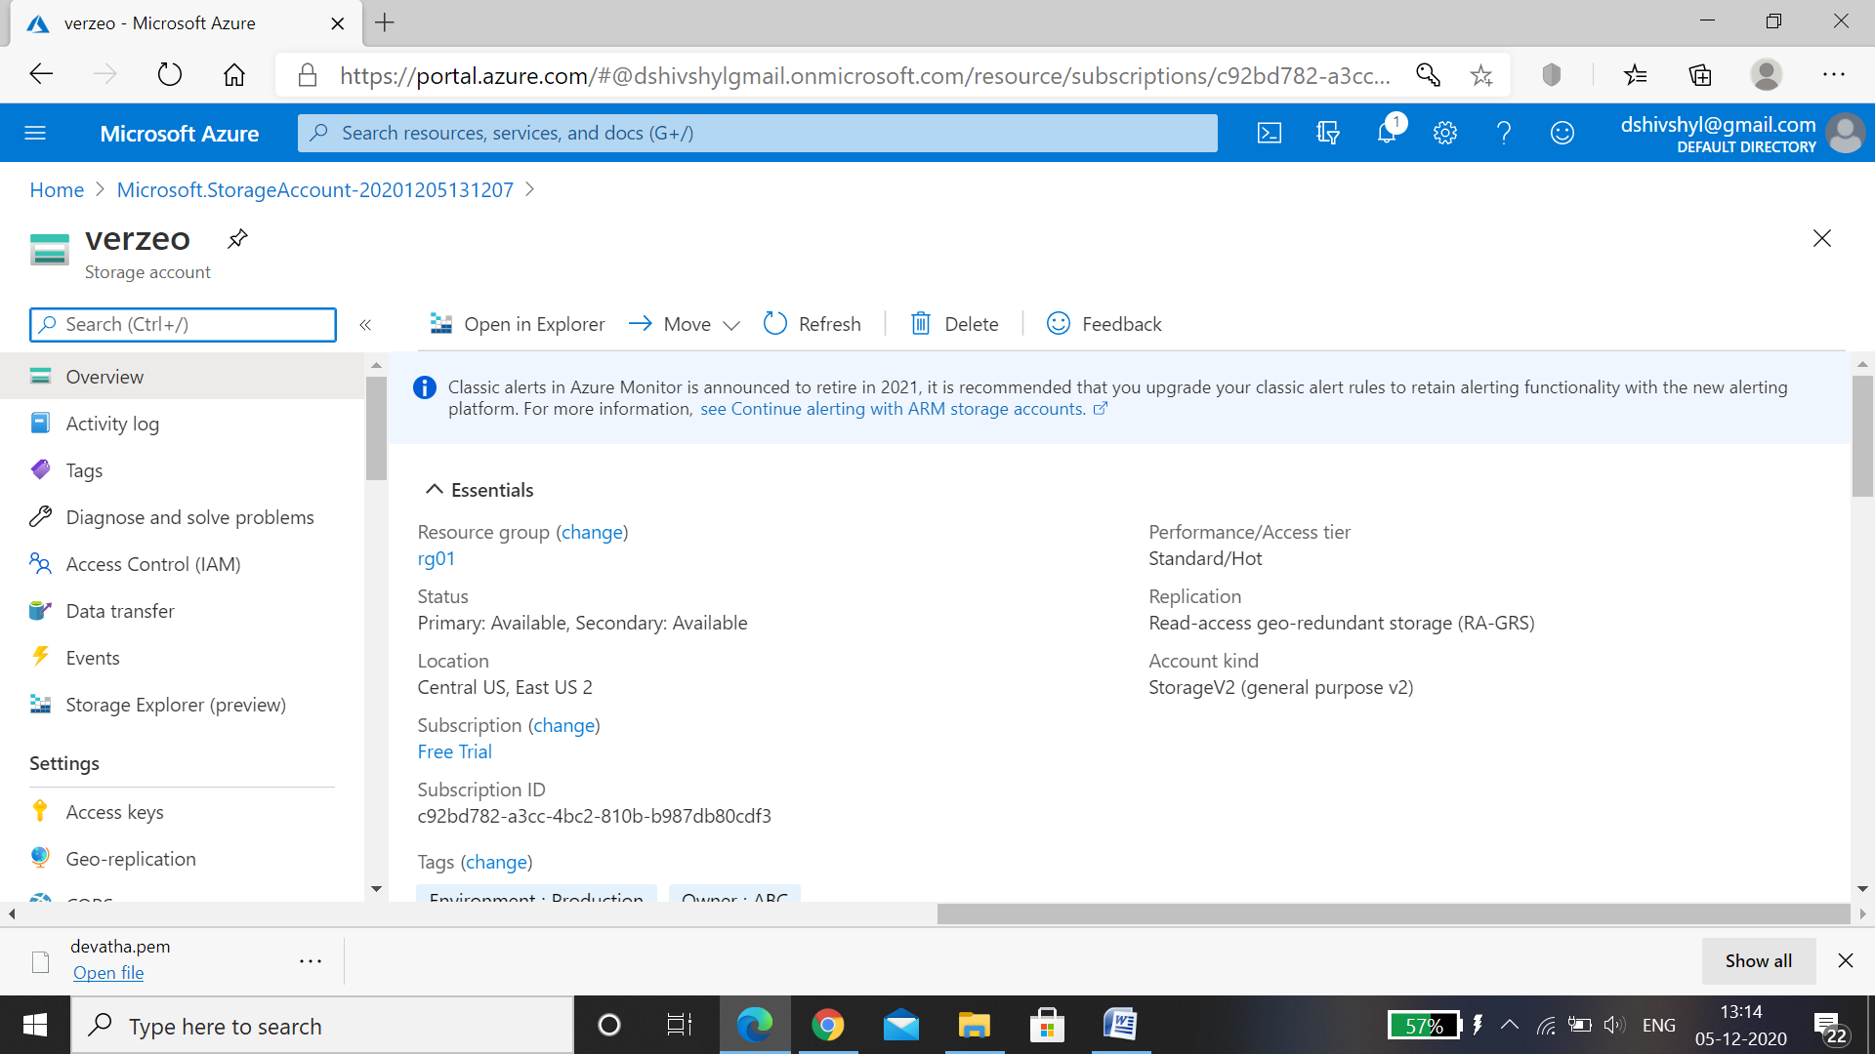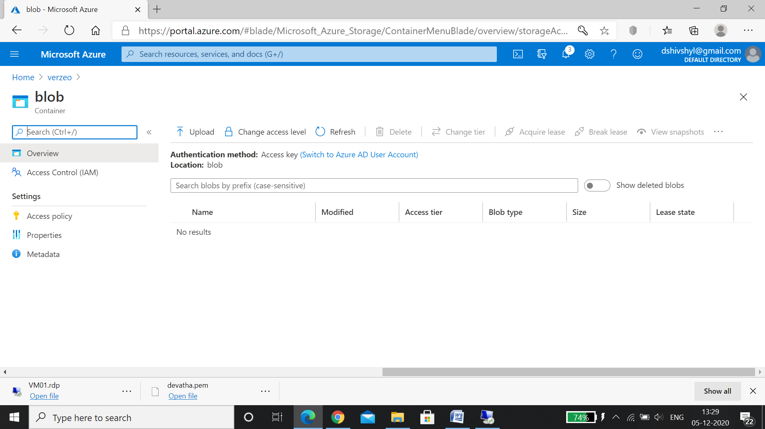

* File share: Blob storage is a feature in Microsoft Azure that lets developers store unstructured data in Microsoft's cloud platform. This data can be accessed from anywhere in the world and can include audio, video and text. Blobs are grouped into "containers" that are tied to user accounts.
* File Share(Share01) is created and mounted on virtual machine VM01.

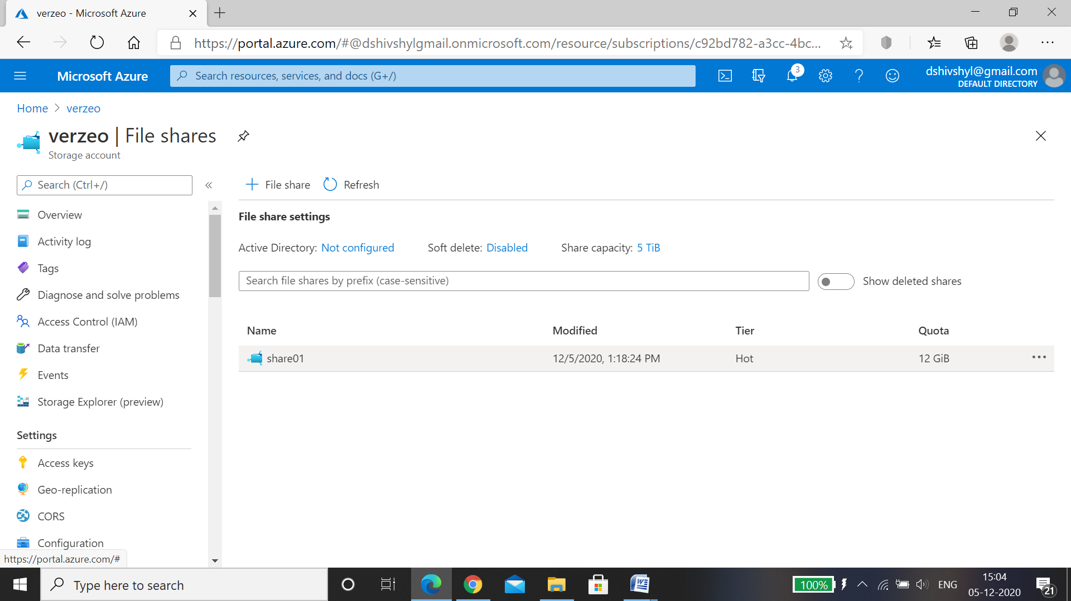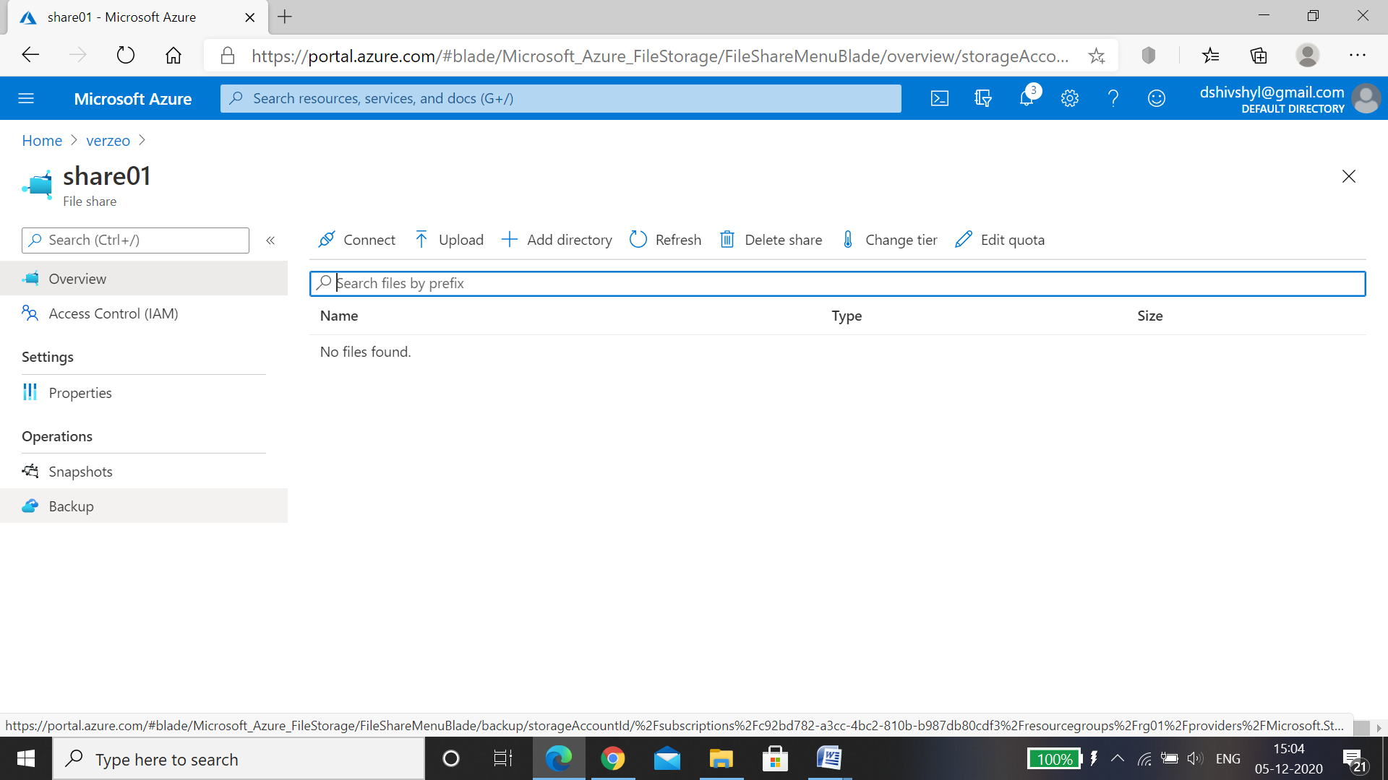

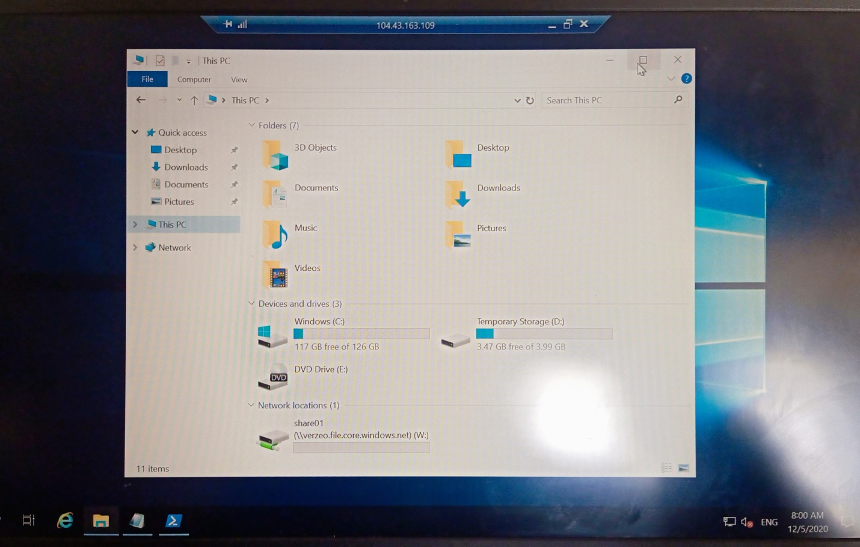

* Network security group.

A Network Security Group consists of a set of access control rules that describe traffic filters. These can be associated with a virtual machine or a subnet in the same region. The rules defined in the Network Security Group act as filters. On the ingress path they are applied before traffic enters the VM

* Network security group for VM01.

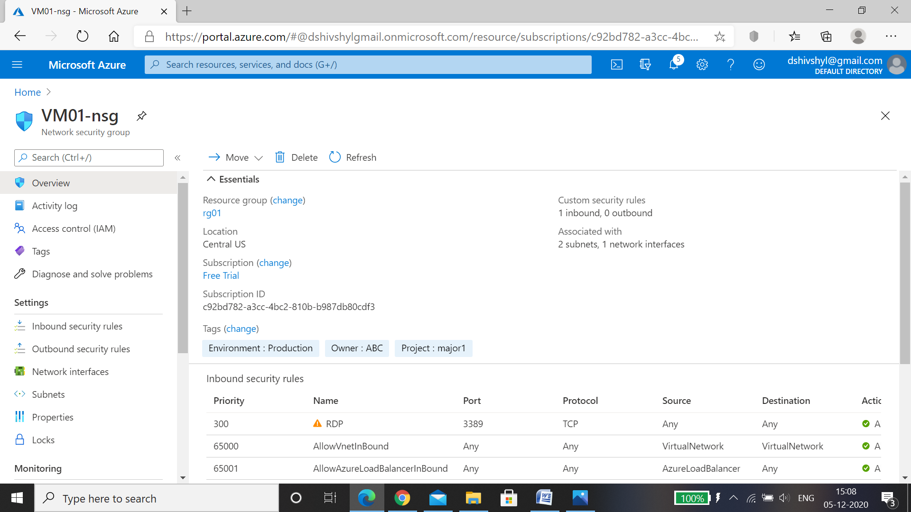

* Network security group for VM02.

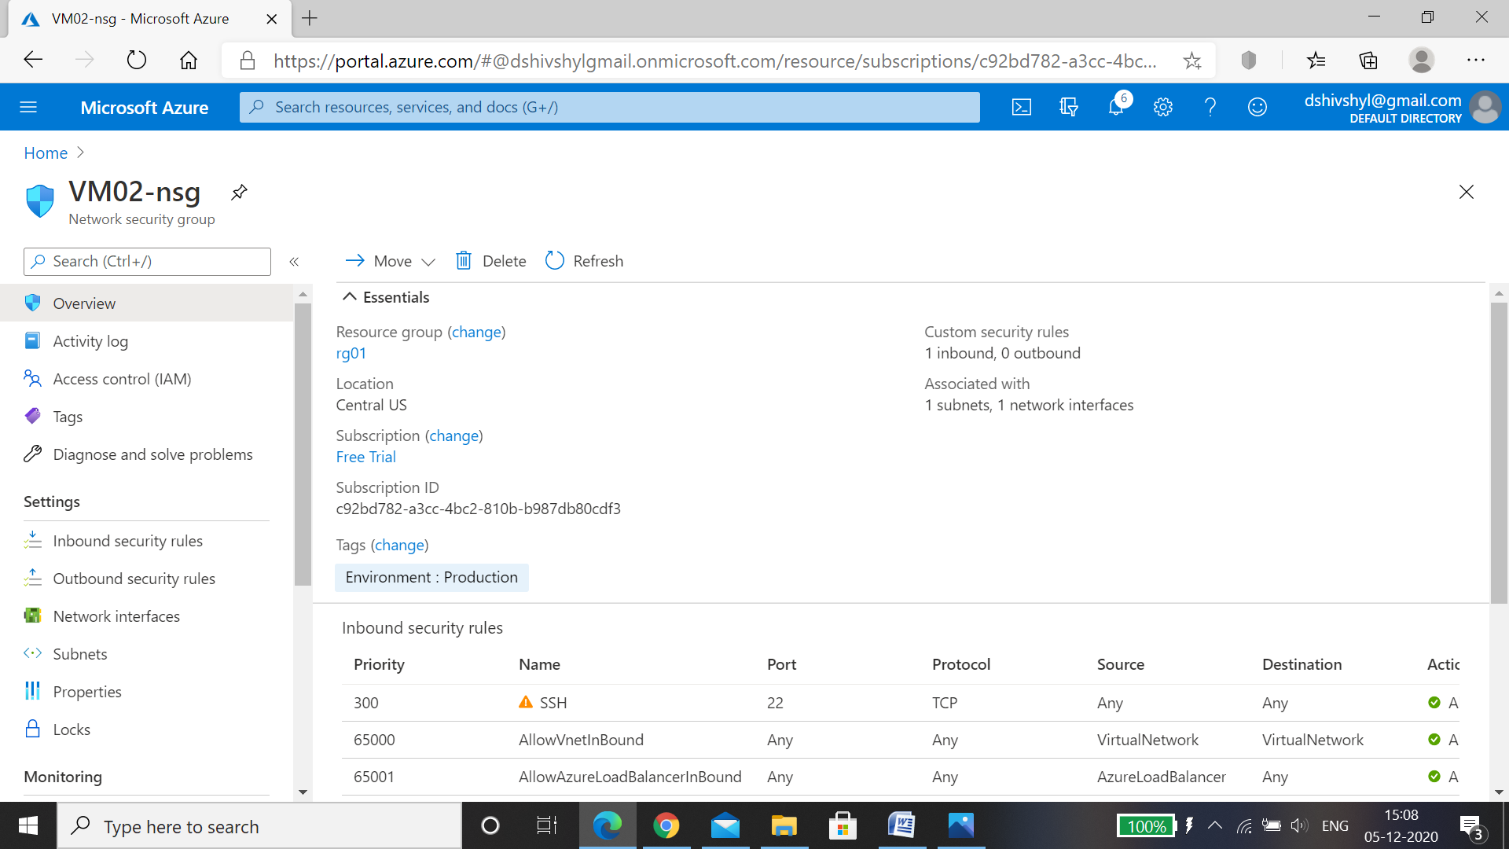

* Configuring an inbound security port rule to allow RDP.

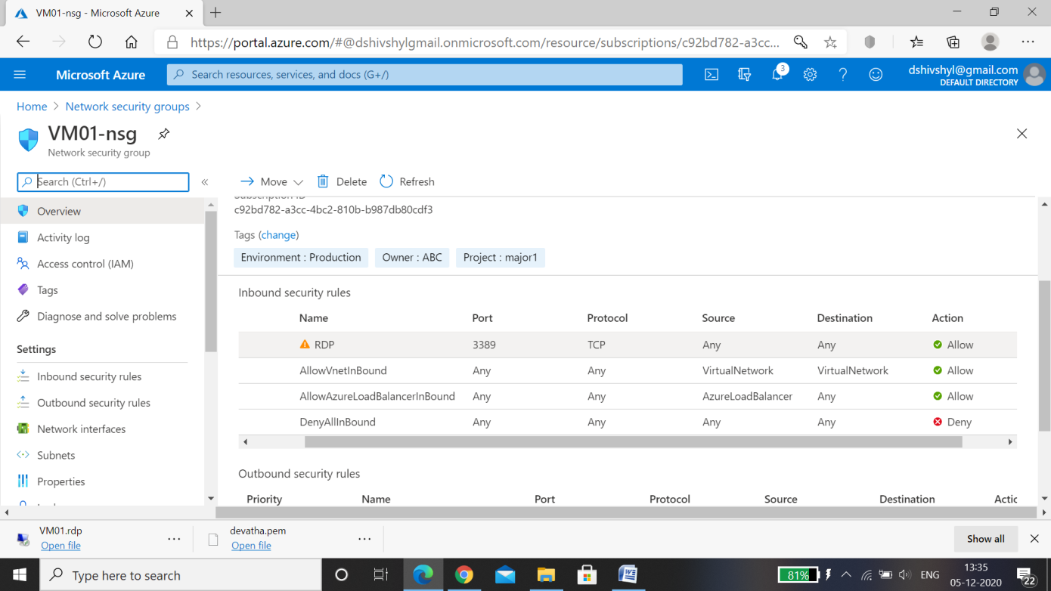

* Configuring an inbound security port rule to allow SSH.

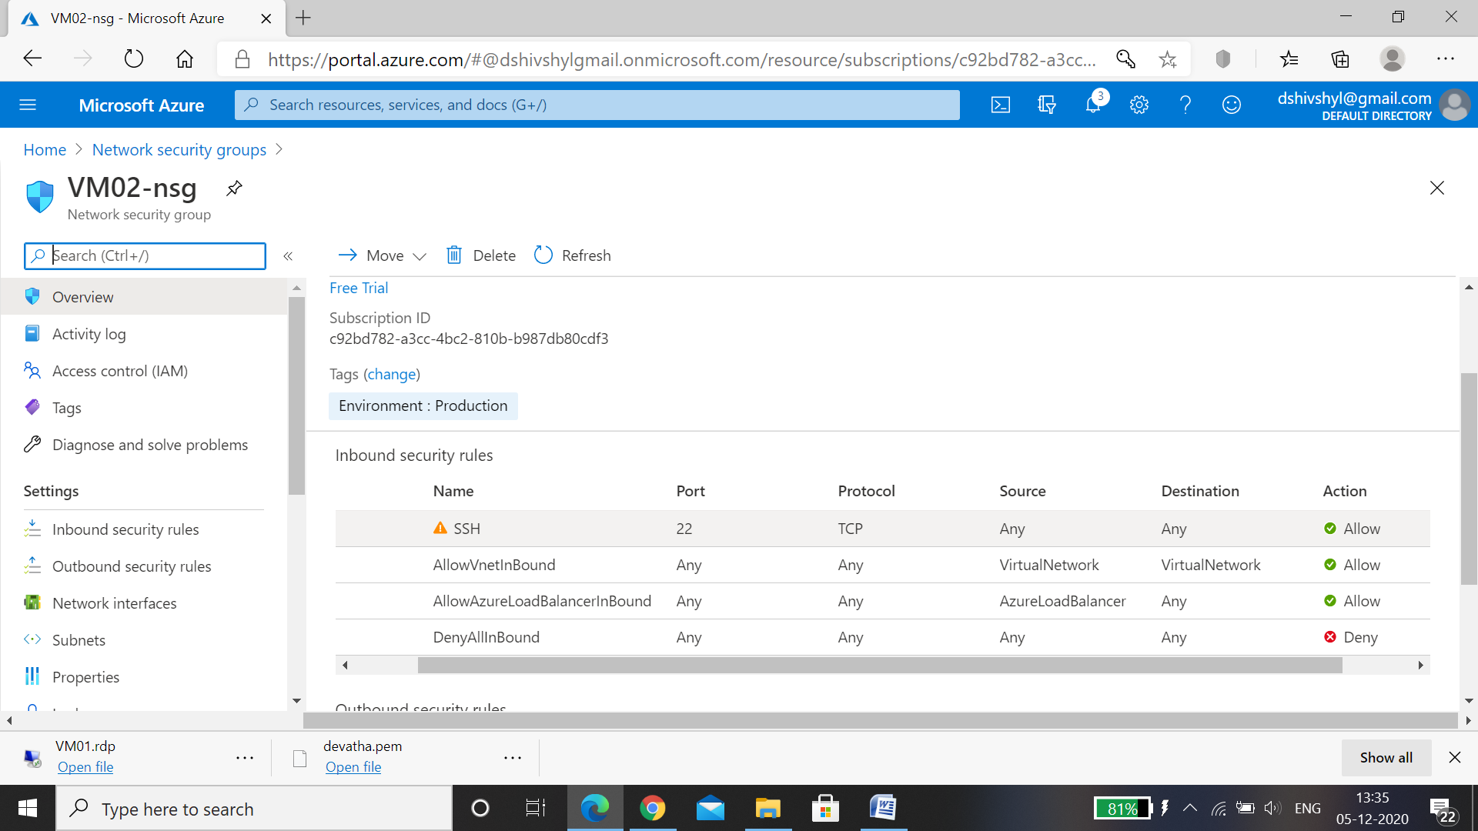

* Peering between the two Virtual Networks.

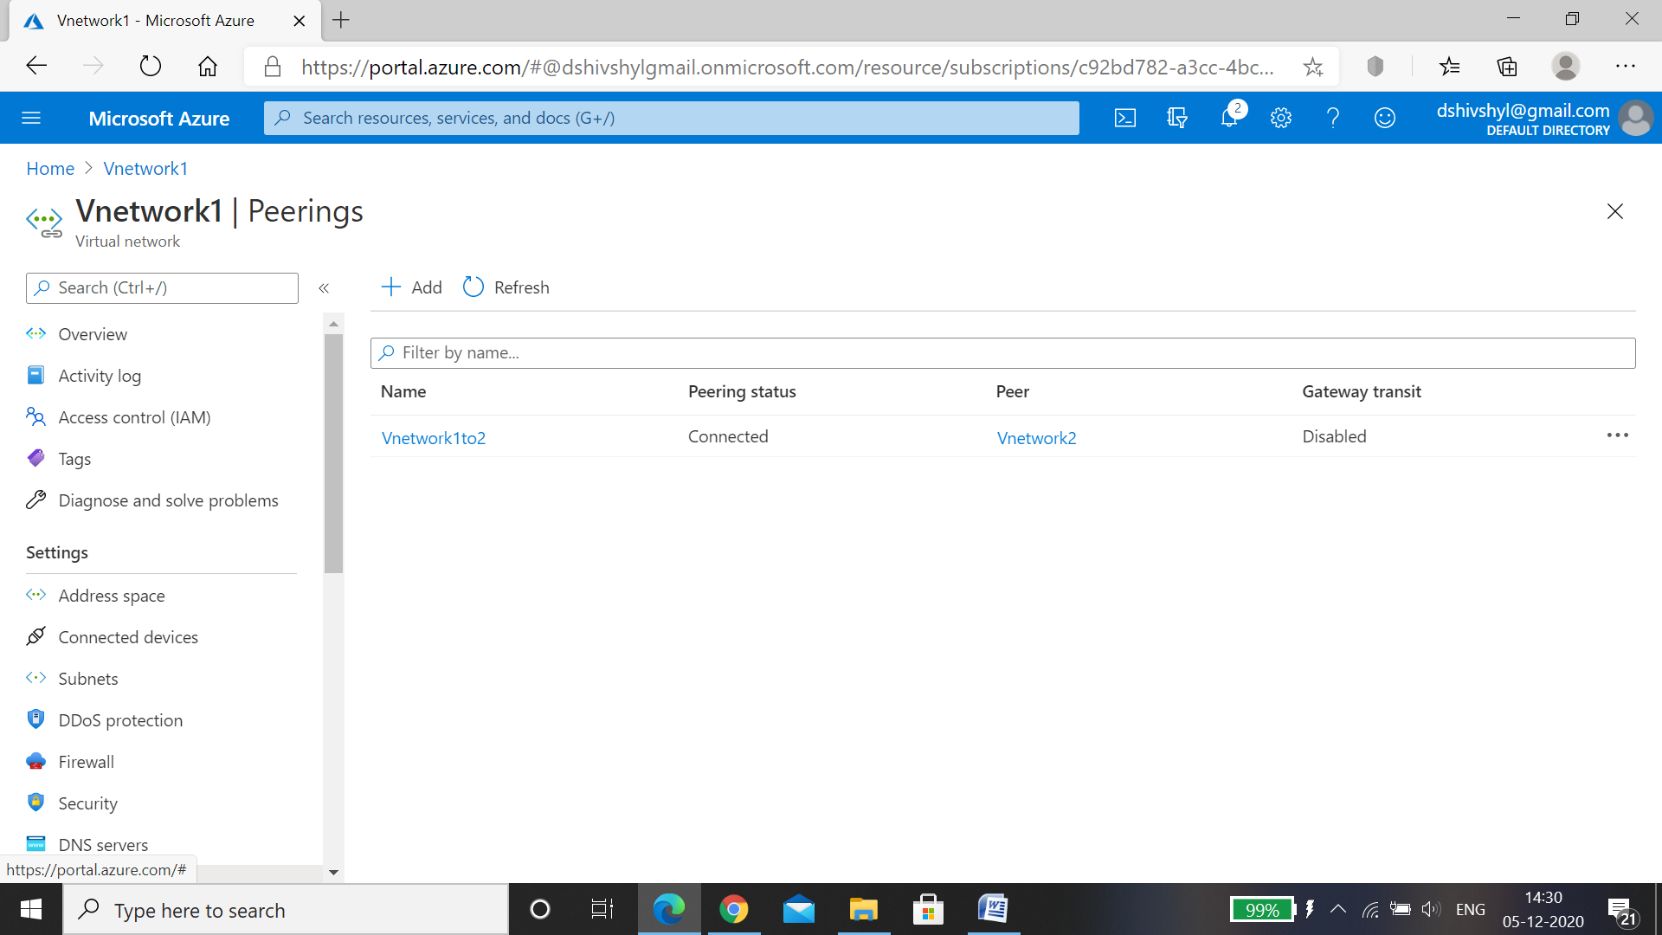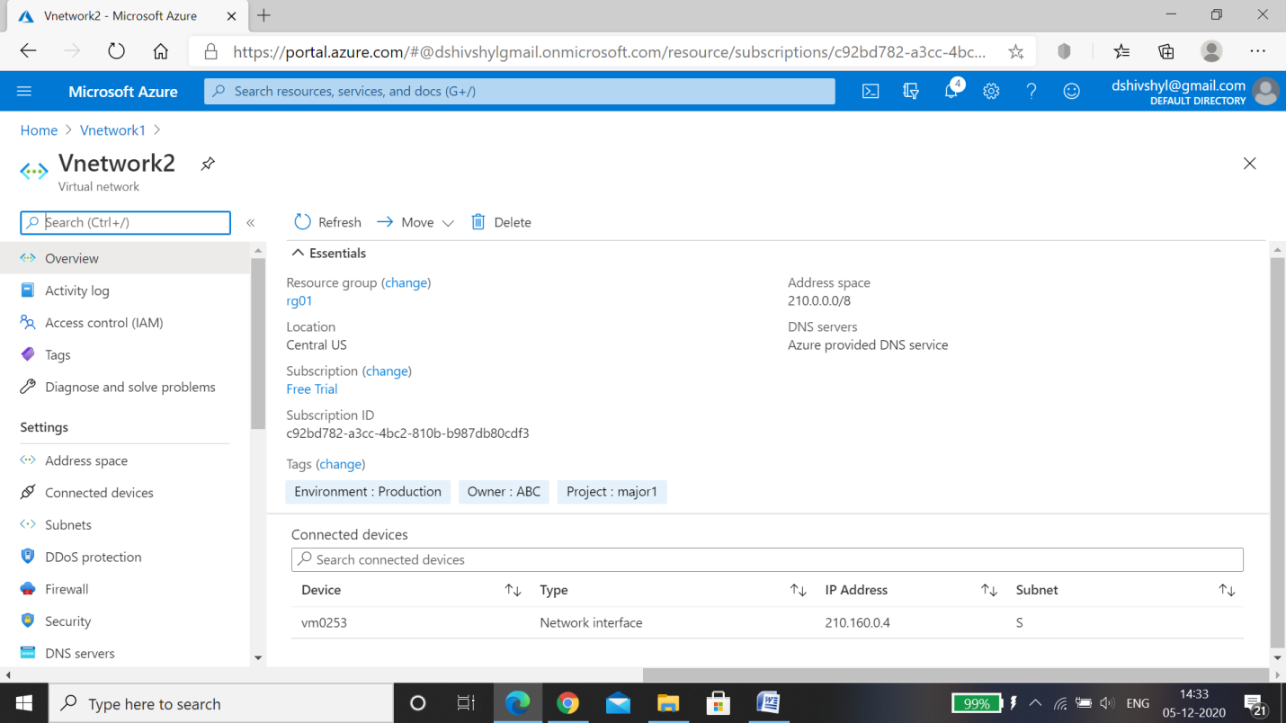

* Recovery Services vault :

A Recovery Services vault is a storage entity in Azure that houses data. The data is typically copies of data, or configuration information for virtual machines (VMs), workloads, servers, or workstations. ... Recovery Services vaults support System Center DPM, Windows Server, Azure Backup Server, and more.

* A Recovery Services vault (Rsv01) in the Resource Group (rg01).

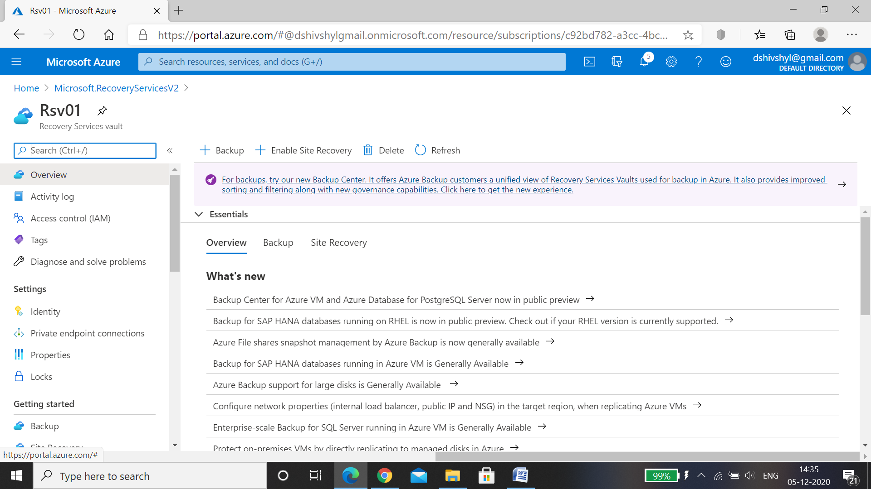

* BackUp:

VMware **backup** is the copying of data on a **virtual machine** (**VM**) in a VMware environment to prevent data loss. VMware **backup**, and **virtual** server **backup** in general, is a common challenge for storage and **backup** administrators. ... This allows for fast complete restoration of a **VM**.

* Define Custom policy for Window VM Backup.
* Setup Backup for the Virtual Machine (Windows) and ensure backup is completed successfully.

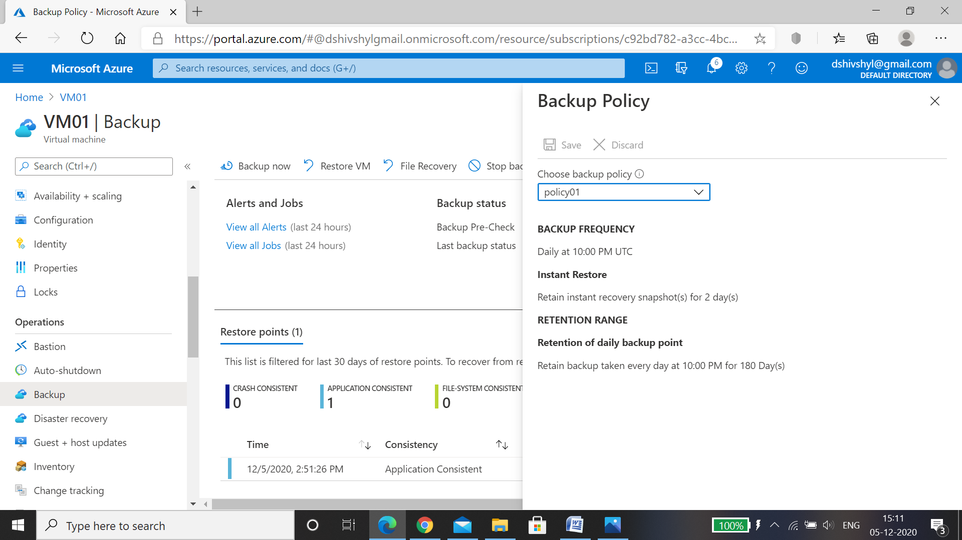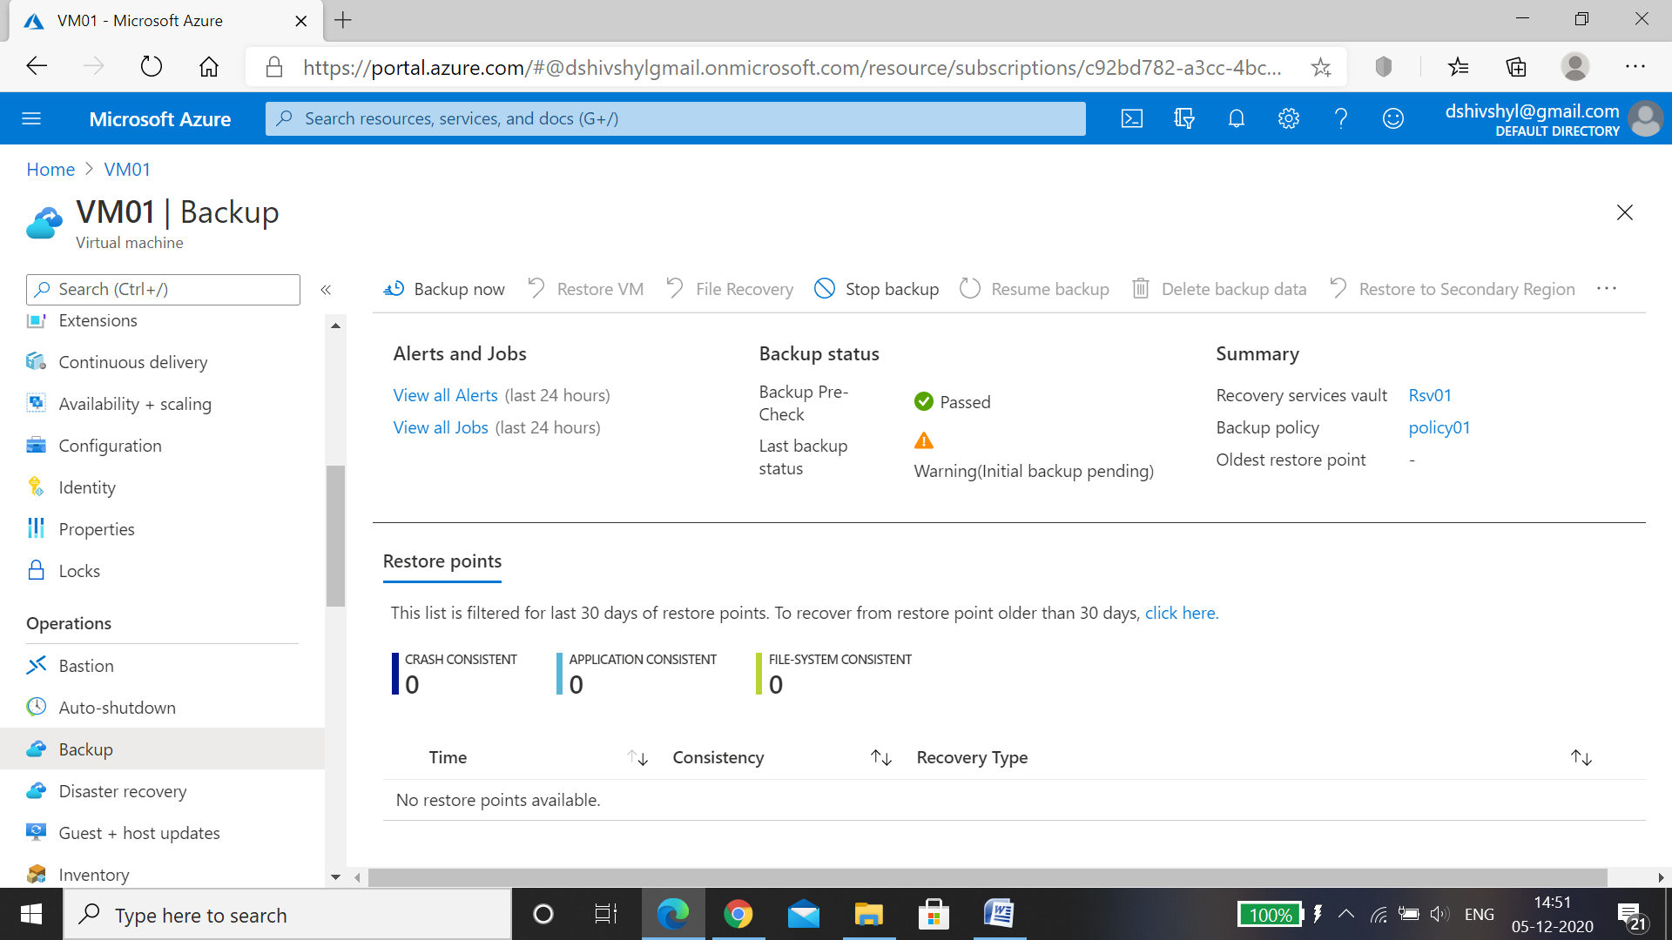

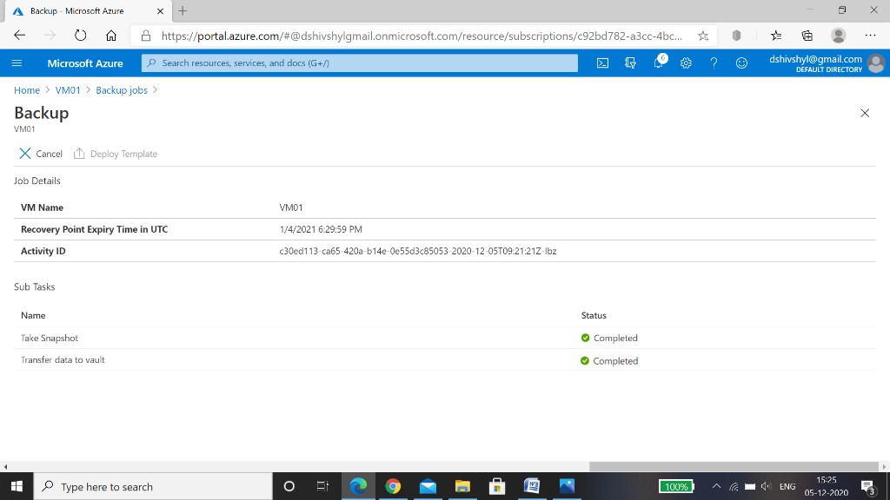

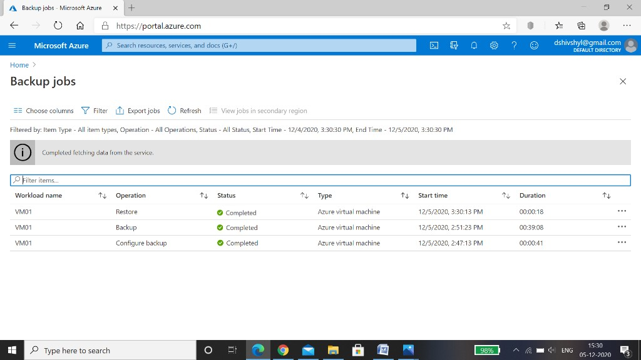

* Apply a lock on the (rg01) and test if you are allowed to delete any resource

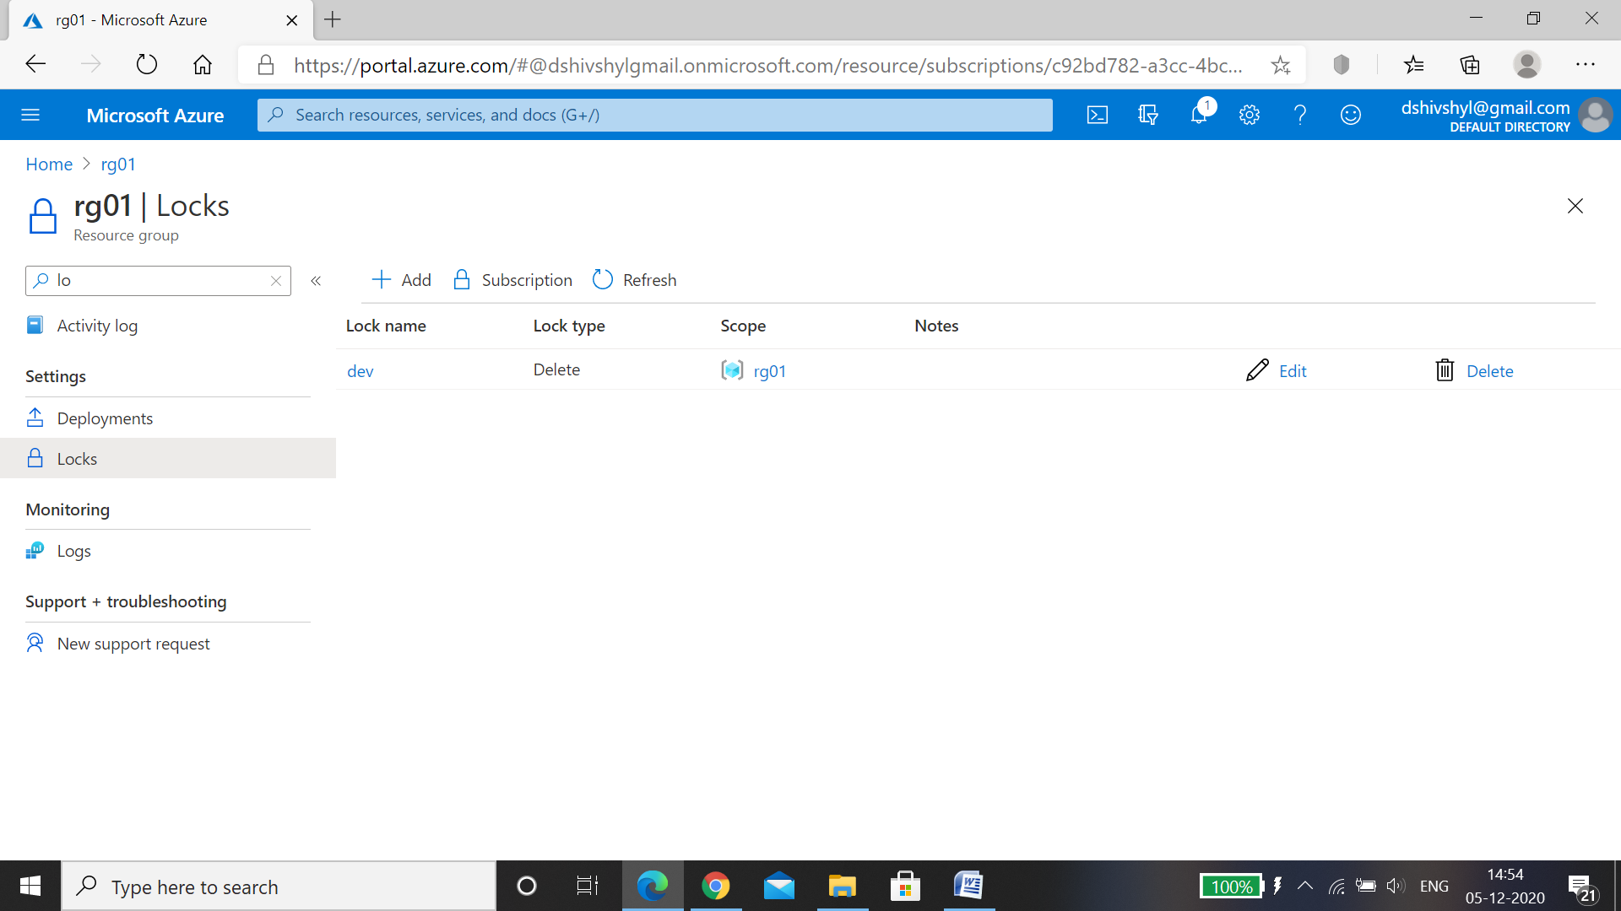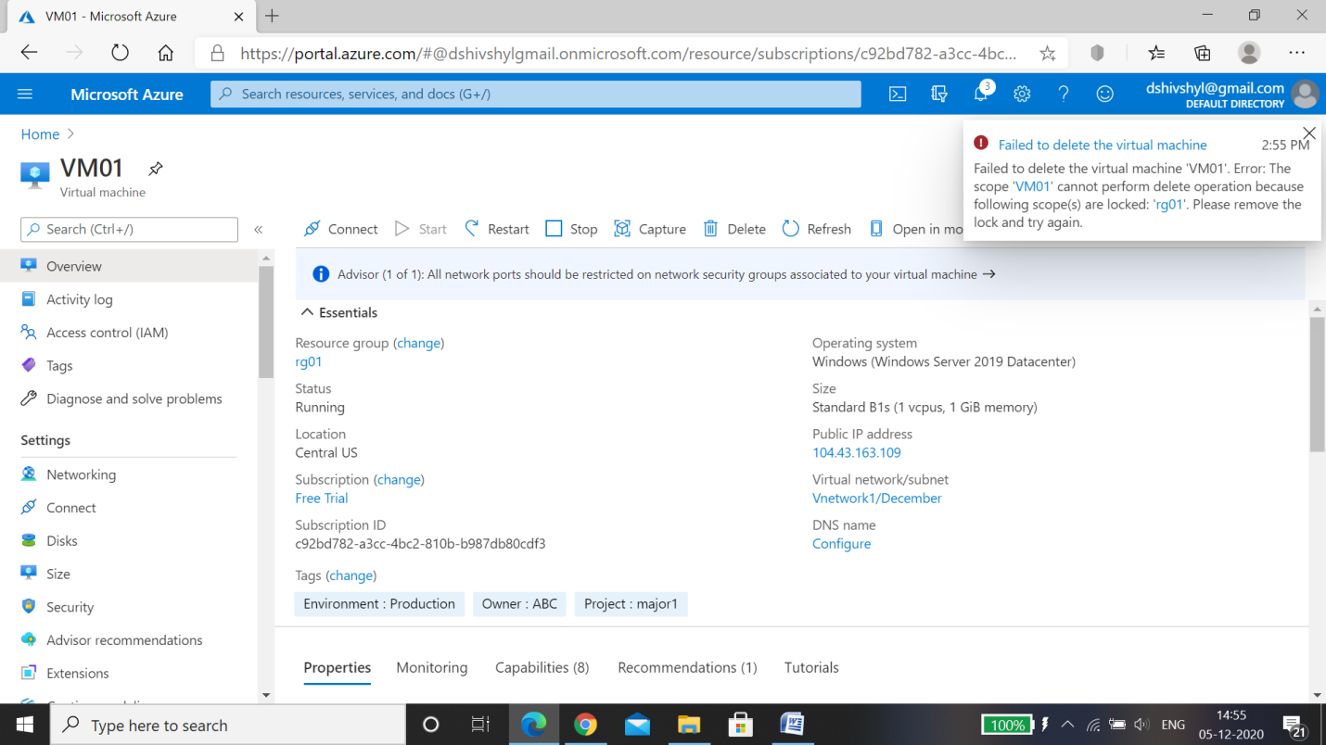

We are not allowed to delete any resource as the resource group is locked.

* Last step of this project is to Remove the lock and delete all the resources, All the resources are deleted successfully.